INTRO & MOTIVATION
In semiconductor manufacturing, automated defect classification systems are increasingly used to analyze wafer maps and identify spatial patterns of faulty die, making rapid and accurate defect detection essential for quality control. While classical deep learning remains the gold standard for such systems, exploring Quantum Machine Learning (QML) models as a future alternative is essential to prepare for the post-NISQ era. Recent developments in quantum algorithms may provide new ways to represent high-dimensional data or construct nonlinear decision boundaries through quantum feature spaces and variational quantum circuits, allowing for rapid classification beyond current classical models.

This project proposes to investigate whether QML classifiers can be applied to the problem of semiconductor wafer defect classification. The goal is to implement and benchmark several QML algorithms and compare their performance with classical machine learning approaches.

The models will be trained on the MixedWM38 WaferMap dataset, a publicly available dataset of semiconductor wafer maps used for academic research in defect detection. This dataset contains approximately 38,000 wafer images, each represented as a 52 × 52 grid. Each pixel corresponds to a die on the wafer and is labeled as: 0 (no die), 1 (functional die), or 2 (defective).

Many wafers exhibit spatial patterns of defects caused by fabrication process issues. These defect patterns can have several characteristic forms, and each wafer is labeled with an 8-dimensional Boolean vector indicating which defect patterns are present, including: (1) center defects, (2) donut-shaped, (3) edge-localized, (4) edge-ring, (5) localized clusters, (6) near-full wafer failure, (7) scratches, and (8) random defects.

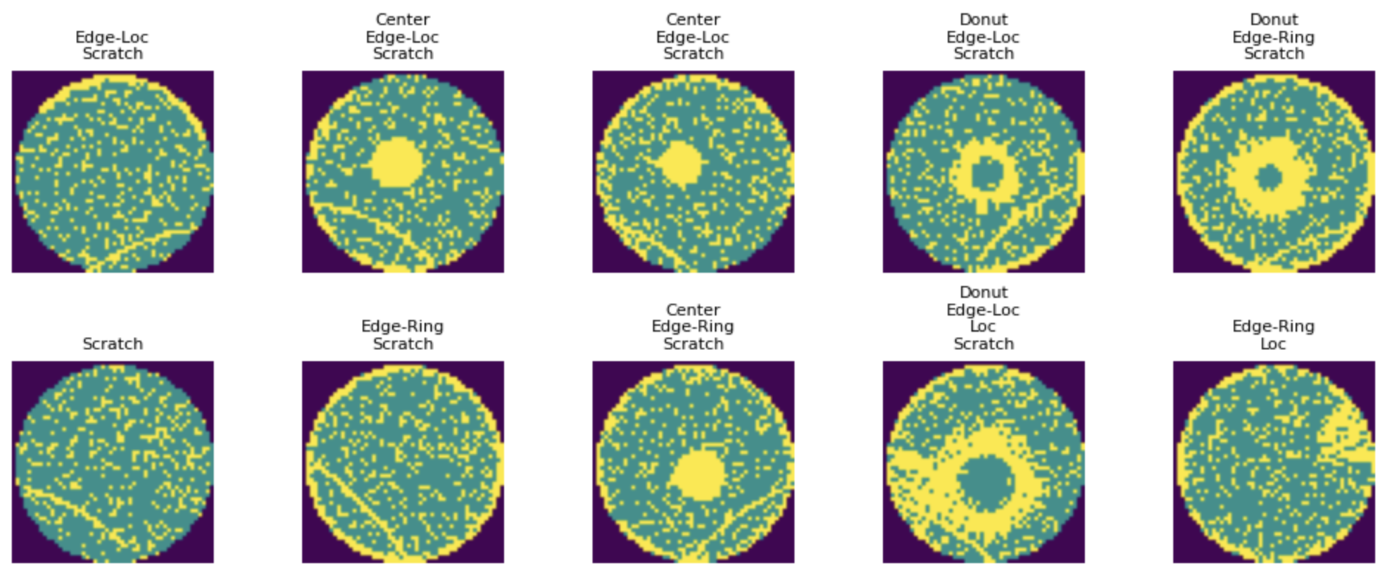

The objective of this project is to build machine learning models that can correctly classify wafers into these defect categories.

Defects introduced during semiconductor wafer fabrication can reduce yield, making rapid and accurate defect detection essential for quality control. Automated defect classification systems are increasingly used to analyze wafer maps and identify spatial patterns of faulty dies. At the same time, quantum machine learning (QML) algorithms have recently been proposed as a way to exploit high-dimensional quantum feature spaces and parameterized quantum circuits for data analysis. While QML methods have shown promise on small synthetic datasets, their performance on realistic industrial datasets remains largely unexplored. This project investigates whether quantum machine learning classifiers can be applied to the problem of semiconductor wafer defect classification.

The experiments will use the MixedWM38 WaferMap dataset, a publicly available dataset of semiconductor wafer maps used in defect detection research. The dataset contains approximately 38,000 wafer images represented as 52 × 52 grids, where each pixel corresponds to a die on the wafer. Pixel values indicate whether the die is absent, functional, or defective. Many wafers exhibit spatial patterns of failure caused by fabrication process issues. These patterns can take several characteristic forms such as center defects, edge-localized defects, scratches, donut-shaped defects, and other spatial structures. Each wafer is labeled using an 8-dimensional Boolean vector indicating which defect patterns are present. The goal of this project is to develop machine learning models capable of correctly identifying these defect patterns.

Because each wafer image contains 52×52=2704 pixels, directly encoding the raw data into a quantum circuit is not feasible with current quantum hardware. To address this limitation, classical dimensionality reduction will be applied before the quantum models are used. Specifically, the images will be flattened and compressed using Principal Component Analysis (PCA) to produce a low-dimensional feature vector containing approximately 10–15 principal components. This allows the dataset to be encoded into quantum circuits with a manageable number of qubits while preserving most of the relevant variance in the data.

Two quantum machine learning models will be implemented and evaluated. The first model is a quantum kernel support vector machine (QSVM). In this approach, a quantum circuit defines a feature map that embeds classical input data into a high-dimensional Hilbert space. The similarity between two data points is computed using the quantum kernel
$$K_{ij}={\left|\left\langle ϕ\left(x_{i}\right) | ϕ\left(x_{j}\right)\right\rangle \right|}^{2}$$
which measures the overlap between quantum states generated by the feature map. The resulting kernel matrix is then used by a classical support vector machine to determine the optimal decision boundary. Because the quantum circuit defining the feature map is fixed, the learning process occurs during the classical SVM optimization.

The second model is a variational quantum classifier (VQC). In this approach, a parameterized quantum circuit acts as a trainable model analogous to a neural network. Classical data is encoded into quantum states, after which a sequence of parameterized gates is applied. The circuit parameters are optimized using gradient-based methods to minimize a classification loss function. Because the wafer dataset is multi-label, the classification task will be implemented using a one-versus-rest strategy, training separate binary classifiers for each defect type.

Both models will be implemented using Python-based quantum machine learning frameworks, including Qiskit Machine Learning and PennyLane. Quantum circuits will be executed on classical quantum simulators. Model performance will be evaluated using standard classification metrics such as accuracy, F1 score, and ROC-AUC, and results will be compared against classical machine learning baselines such as support vector machines and logistic regression. By applying QML methods to a realistic semiconductor manufacturing dataset, this project aims to explore whether quantum feature maps or variational circuits offer advantages for identifying spatial defect patterns in wafer maps.

This project does not seek to outperform state-of-the-art classical models. Instead, it serves as a proof-of-concept to demonstrate that QML algorithms—specifically Quantum Kernel Methods and Variational Circuits—can successfully ingest and classify industrial-scale data like the MixedWM38 dataset. By establishing a baseline of QML feasibility today, we contribute to the development of "quantum-ready" diagnostic pipelines for future fault-tolerant processors.

I am proposing to build quantum machine learning classifiers that can identify and correctly label defects in semiconductor wafers. The idea is to build, test, and benchmark several QML algorithms using two different libraries: Qiskit and Penny Lane. The three QML algorithms are (1) Quantum SVM kernel, (2) Variational Quantum Classifier, and (3) Quantum Convolutional Neural Network.

I already have a dataset that has been cleaned and published academic research purposes, the WaferMap dataset MixedWM38. This is a dataset provided by [who?], consisting of 38,000 2D images of semiconductor wafers in a 52x52 pixel format. Each pixel represents a semiconductor die which is given one of 3 labels: 0 (no die), 1 (good), and 2 (defect). There may be structural patterns of defects across a wafer, and these defect patterns are encoded in a set of 8-dimensional Boolean vectors flagging one or several defect patterns.

The data will need to be processed for quantum computing purposes. For example, each image is a 52x52=2704 pixel dataset, but current quantum computers (and even the more advanced simulators) can only handle dozens of logical qubits rather than thousands. Therefore we need to use a dimensionality reduction technique like Principal Component Analysis (PCA) to reduce the number of features to 20 or fewer.

Current option is to apply QML techniques on a semiconductor defect dataset.
- Classify defects using a quantum kernel (SVM or...?).
  - Because there are too many features (52x52=2704 sites), the first step is to apply classical feature extraction using PCA or some other form of dimensionality reduction to get the features to a manageable 15 or so features.
  - This approach uses a quantum circuit only to compute a similarity (kernel) between data points. The quantum circuit defines a feature map into a high-dimensional Hilbert space, and the classifier (QSVM) finds a separating hyperplane in that space. There are no trainable quantum parameters, i.e. the quantum circuit is fixed, and this happens in the classical SVM optimization [how does it learn?]. They key object is the kernel matrix K_ij = |<o(xi)|o(xj)>|^2
  - Benchmark performance against classical SVM methods using metrics like F1 score, ROC-AUC, accuracy, etc.
  - Qiskit and PennyLane may have quantum SVM kernels available
  - Qiskit ML quantum kernel machine learning https://qiskit-community.github.io/qiskit-machine-learning/tutorials/03_quantum_kernel.html
  - Penny Lane kernel-based training of quantum models https://pennylane.ai/qml/demos/tutorial_kernel_based_training
- Variational Quantum Classifier
  - The idea is to replace a classical classifier with a parameterized quantum circuit trained via gradient descent. This is a trainable quantum neural network.
  - Similar to the first, the algorithm starts with classical PCA to reduce dimensionality to a manageable number. Because the problem is multi-label, you would probably need to train 8 binary classifiers.
  - The quantum parameters are trained to minimize a loss function.
  - Penny Lane VQC: https://pennylane.ai/qml/demos/tutorial_variational_classifier
  - Qiskit VQC https://qiskit-community.github.io/qiskit-machine-learning/tutorials/02_neural_network_classifier_and_regressor.html
- Quantum Convolutional Neural Network
  - Qiskit ML CNN https://qiskit-community.github.io/qiskit-machine-learning/tutorials/11_quantum_convolutional_neural_networks.html
  - Penny Lane demo is outdated: https://pennylane.ai/qml/demos/tutorial_quanvolution

The core dataset is the WaferMap Dataset: MixedWM38. Each image is a 52x52 map of a silicon wafer, and each pixel value represents one die on the wafer. The label “1” is a good die, and the label “2” is a failed die. Some of the wafers exhibit two-dimensional patterns of failed dies, like a streak or a donut. We want to build a QML model that can distinguish between the 8 different kinds of structural defects

Qiskit Machine Learning https://qiskit-community.github.io/qiskit-machine-learning/index.html
Penny Lane Guide to QML: https://pennylane.ai/topics/quantum-machine-learning

